**NEPAL COLLEGE OF INFORMATION TECHNOLOGY**

Level: Bachelor Unit Test Year: 2013

Program: BEIT(II) Full marks: 70

Course: Electronic Devices Time: 2hrs

Attempt all the questions

1. a) State the properties of nonlinear devices. Taking an appropriate example, show that nonlinear device doesn’t follow principle of superposition. (3+4)

b) Find IS and VS for the circuit shown below and also find the piecewise linear model of the square law device of the circuit. (8)

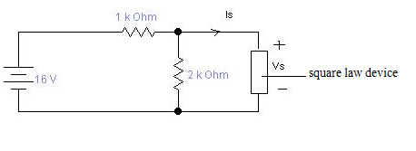

Assume IS=A(VS -VTR)2  where A=1mA/V2 and VTR=0.

2. a) What happens to a diode when it is: (8)

i) Forward Biased

ii) Reverse Biased

b) Explain reverse recovery time of diode with necessary waveform. (7)

3. a) Determine the range of values of Vin that will maintain the zener diode in the “ON” state. Also find the maximum power that can be dissipated to the diode. (7)

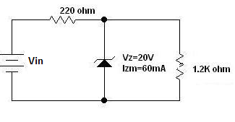

b) “Tunnel diode possesses negative resistance.” Justify this statement with the help of VI characteristics of tunnel diode. (8)

OR

Explain piecewise linear modeling of a diode and find the piecewise linear model of a diode (silicon) with IS=10-11A and η=1.6 in the vicinity of the operating point ID=1mA.

4. a) Explain the operation of a half wave rectifier with necessary circuits and waveforms and also find its efficiency. (5)

b) Draw output waveform (assume ideal diode). (5+5)

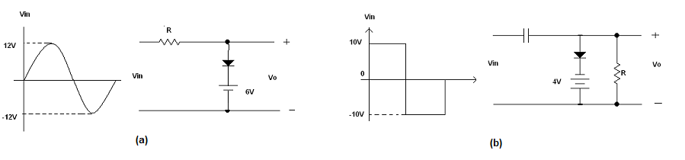

5. Write short notes.(any two) 2×5

1. Transition and Diffusion capacitances
2. Extrinsic semiconductor
3. Depletion region